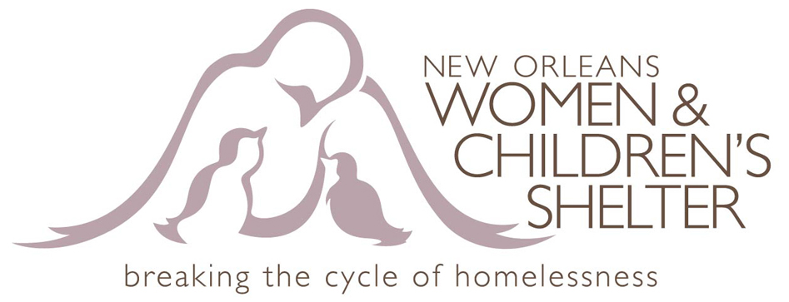

New Orleans Women & Children’s Shelter Wish List
Transitional Assistance Program
“TAP”

House Hold Items Starter Kit
Twin Comforters
Mattress Covers and Pillow Covers
Pot & Pans
Set of dishes, Beverage Glasses/cups
Utensils, Dinner Ware (forks, spoons, etc.)

Kitchen Appliances:
Can Opener, Coffee Pot, Toaster
Kitchen Trash Can and Trash Bags
Dish Towels & Pot Holders

Cleaning Supplies:
Mop and Bucket, Broom and Dust Pan
Cleaning Supplies
Fabulous

